Michelangelo’s Pieta is a marble sculpture in which the artist worked on and completed between the years 1498 and 1499. Pieta is a term given to an art work or scene based from Christianity in which the Virgin Marry is cradling and morning a figure of Jesus Christ who has passed away. This Pieta, being one of a few others sculpted by Michelangelo, was commissioned by the French cardinal Jean de Billheres to be located in the Old St. Peter’s Basilica. This sculpture was signed by Michelangelo which seems to indicate his great enthusiasm for this piece being that it is the only artwork he ever signed. Other examples of Pieta sculptures by Michelangelo are: The Deposition, The Rondanini Pieta and The Palestrina Pieta.

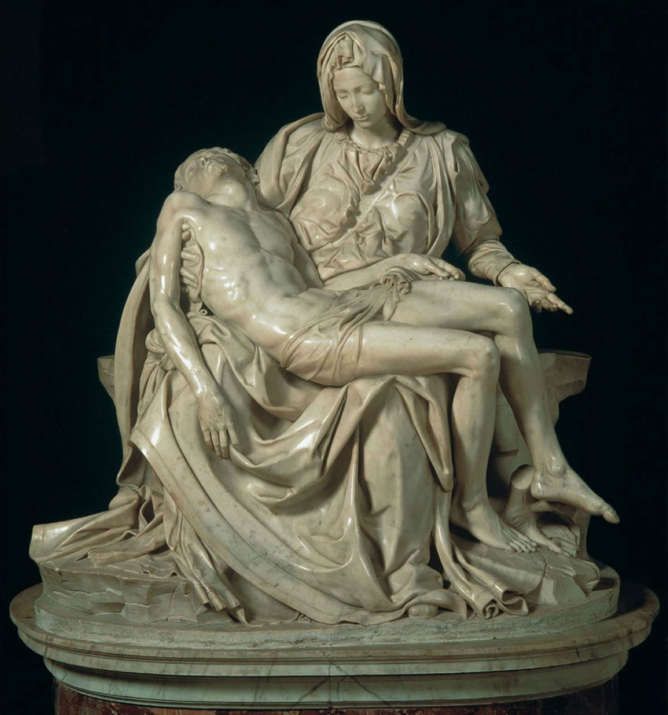

From George Washington to Barack Obama presidential portraits have been traditionally commissioned by a sitting president of the United States. The artist vary by president generally, with George Peter Alexander Healy being commissioned four times in the 1800’s. For Richard Nixon’s portrait produced early in his presidency, Norman Rockwell was chosen as the painter, this painting noted as being difficult to paint by Rockwell saying Nixon to be “to good looking”. Painted portraits have mostly been completed in oil on canvas and continue to be commissioned by todays presidents even when photography would be an easier and quicker way to capture their likenesses.

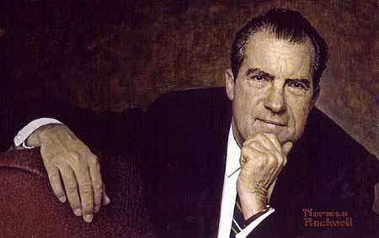

Citations:

Reference:

Marilyn, Michael Cothren. (11/2011) Art: A Brief History, 5th Edition. Pearson Learning Solutions.

Michelangelo's Pieta Sculpture. (n.d.). Retrieved January 13, 2016, from http://pietamichelangelo.com/

Voss, F. (n.d.). Portraits of the Presidents from the National Portrait Gallery. Retrieved January 13, 2016, from http://npg.si.edu/exh/travpres/index6.htm

Image:

From Old St. Peter’s. c. 1500. Marble, height 5′ 8½″ (1.74 m). St. Peter’s, Vatican, Rome. (Stokstad 333-334)

Norman Rockwell (1894-1978). Richard Nixon. Oil on canvas, 1968 National Portrait Gallery, Smithsonian Institution